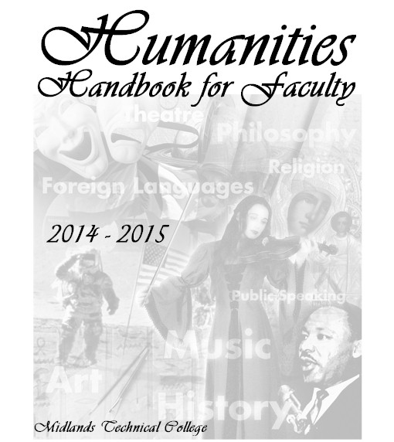

**IMPORTANT CONTACTS**

|  |  |  |  |  |
| --- | --- | --- | --- | --- |
| ***EMERGENCIES: 738-7199 (Security, both campuses)***  ***NON-EMERGENCIES: 738-7850*** | | | | |
| DEPARTMENT CHAIR Elena Martínez-Vidal  Humanities Department Chair  WM 317-A, 738-7707  [vidale@midlandstech.edu](mailto:vidale@midlandstech.edu) | | | | |
| **Midlands Technical College Web Site:** [**http://www.midlandstech.edu**](http://www.midlandstech.edu/)  **Department Web Site:** [**http://www.midlandstech.edu/humanities**](http://www.midlandstech.edu/humanities)  **D2L Access:** [**https://elearn.midlandstech.edu/**](https://elearn.midlandstech.edu/) | | | | |
| **HUMANITIES DEPARTMENT FULL TIME FACULTY** | | | | |
| **Name** | **Discipline** | **Telephone** | **Email User Name** | **Office** |
| Converse, Bruce | Speech | 822-7053 | converseb | RO 201 (AC) |
| Dodd, Colin | Art | 822-3412 | doddc | RO 121 (AC) |
| Gilmer, Rob | History | 738-7785 | gilmerr | WM 426 (BC) |
| Holland, Reid | **History/Coordinator** | 822-3395 | hollandr | RO 112 (AC) |
| Hughes, Donna | Philosophy/Transfer | 822-3344 | hughesd | RO 101 (AC) |
| Kingkade, Helen | Theatre/Speech | 822-3375 | kingkadeh | RO 119 (AC) |
| Moonan, Robert | **Spanish/Coordinator** | 738-7816 | moonanr | WM 301 (BC) |
| Reeder, Mal | Speech | 738-3346 | reederm | RO 110 (AC) |
| Santiago, Enid | Spanish | 822-3564 | santiagoc | RO 205 (AC) |
| Scotti, Tony | **History/ Coordinator** | 738-7815 | scottia | WM 424 (BC) |
| Stout, Cindy | Speech | 738-7670 | stoutc | WM 411 (BC) |
| Turnage, Scott | History | 822-3301 | turnages | RO 125 (AC) |
| Witkowski, Bob | Speech | 738-7682 | witkowskir | WM 409 (BC) |
|  | | | | |
| ADMINISTRATIVE ASSISTANTS | | | | |
| **Beltline Campus:** | | **Airport Campus:** | | |
| Lisa Cheeks (8:00am-5:00pm)  Departmental Assistant WM 317, 738-7684 [cheeksl@midlandstech.edu](mailto:cheeksl@midlandstech.edu)  Fax: 738-7848 | | Monica Boucher-Romano (7:30am-4:00pm)  [boucherromanom@midlandstech.edu](mailto:boucherromanom@midlandstech.edu)  Administrative Specialist  RO105, 822-3357 | | |
| Tracy Cooper (7:30am-4:00pm) 738-7612  [coopert@midlandstech.edu](mailto:coopert@midlandstech.edu)  Judy Carter, Night Assistant (4:00pm -9:00pm)  [carterj@midlandstech.edu](mailto:carterj@midlandstech.edu)  Administrative Specialists  WM 445, 738-7612 | | Linda Pender (4:00-9:00pm)  RO105, 822-3357  [penderl@midlandstech.edu](mailto:penderl@midlandstech.edu) | | |

|  |  |  |
| --- | --- | --- |
| ADJUNCT RESOURCES | | |
| **Beltline Campus:** | | **Airport Campus:** |
| Workroom: WM 320  Code for Lock: Press #1 and #4 at the same time then press #2. | | Workroom: RO 122 |
| Mailboxes: WM 445 | | Mailboxes: RO 105 |
| **SPECIAL OFFICES** | | |
| **Beltline:** | | **Airport:** |
| Operations (parking sticker, rooms, etc.)  738-7666  WM 113  <http://inside.midlandstech.com/operations/ops%20info.htm> | | Operations (parking sticker, rooms, etc.)  822-3218  OP-106  <http://inside.midlandstech.com/operations/ops%20info.htm> |
| Academic Success Center  WM 110, 738-7817  <http://www.midlandstech.edu/successcenter/> | | Academic Success Center  AC 151, 822-3545 |
| Counseling Services  738-7636 | | Counseling Services  822-3505 |
| Testing Center  738-7730 | | Testing Center  822-3659 |
| **SPECIAL OFFICES (both campuses)** | | |
| Security 738-7850 **EMERGENCIES 738-7199**  **ON CAMPUS PHONES ONLY: 7199**  **If you know you will need security ahead of time, call Chief Sauls at 822-3297** | Mary Holloway - AVP, Student Development Services  [hollowaym@midlandstech.edu](mailto:hollowaym@midlandstech.edu)  822-3529  Hart Hayden, Coordinator, Campus Life  [haydenh@midlandstech.edu](mailto:haydenh@midlandstech.edu)  822-3441 | |
| Cindy Rogers Faculty Resource DirectorWM 304A, 738-7889[rogersch@midlandstech.edu](mailto:rogersch@midlandstech.edu) | Library: Laura Baker  Instructional Librarian  AC 234, 822-3533  [bakerl@midlandstech.edu](mailto:bakerl@midlandstech.edu) | |
| Wilfred Jeffcoat  Fort Jackson: Coordinator  782-3213  [jeffcoatw@midlandstech.edu](mailto:jeffcoatw@midlandstech.edu) | Morris Lewis, Media Services Manager  Copy Center  MH 101- Airport Campus, 822-3393  [lewism@midlandstech.edu](mailto:lewism@midlandstech.edu) | |
| **MEDIA AND COMPUTER ASSISTANCE (both campuses)** Multi-media and AV Help Line 822-3550 | Morris Lewis, Media Services Manager  Copy Center  MH 101- Airport Campus, 822-3393  [lewism@midlandstech.edu](mailto:lewism@midlandstech.edu) | |
| Computer Help Line 738-7888 | Keys for Multimedia Cabinets:  BC: Lisa Cheeks (Humanities Faculty only) | |

**FACULTY RESPONSIBILITIES**

As an adjunct faculty member, you are required to

* meet all classes according to the college schedule
* teach courses effectively with all course specific content given
* to observe departmental and college policies and guidelines
* give students a syllabus with a schedule that the class will follow
* syllabus must be the latest syllabus (available at Humanities Department Course under Student tab in D2L)
* return contracts in a timely manner
* **input Enrollment Verification on time**
* **give student the SLO assessments as requested**
* **remind students about Course Evaluations**
* **return SLO data as requested electronically**
* **input grades when required [Final grades are alphabetical; no pluses or minuses]**
* attend departmental meetings as may be required during the semester
* provide students with some means of contacting you.

Here are some details about these **IMPORTANT** responsibilities:

# CALENDAR: CLASSROOM MANAGEMENT SCHEDULES

Here are some important dates for you to be aware of as well as due dates for completion of Enrollment Verification and Exams. **FOR MORE INFORMATION ON IMPORTANT DATES AND HOLIDAYS PLEASE REFER TO THE 2013– 2014 COLLEGE CALENDAR.**

**FALL 2014**

|  |  |
| --- | --- |
| **FULL SEMESTER COURSES** | |
| 8/25/14 | COURSES BEGIN/SYLLABI UPLOAD TO D2L HUMANITIES DEPARTMENTAL COURSE ASAP |
| 8/29 – 9/04/14 | ENROLLMENT VERIFICATION ONLINE |
| 9/01/14 | Labor Day Holiday/College Closed |
| 10/13 - 10/14/14 | Student Holidays/Faculty Holiday 10/13 and Workday10/14 |
| 11/04/14 | Election Day/College Closed |
| 11/26/14 | Student Holiday/Faculty Workday |
| 11/27 – 11/30/14 | Thanksgiving Holidays/College Closed |
| 12/09/14 | Full Fall CLASSES END |
| 12/11– 12/15/14 | EXAMS |
| 12/16/14 | GRADES DUE ONLINE BY 3:00PM/GRADE BOOK AND ATTENDANCE AND A COPY OF THE FINAL EXAM UPLOAD TO D2L HUMANITIES DEPARTMENTAL COURSE ASAP/SLO DATA DUE |
|  | |
| **FALL I AND FJ I COURSES** | |
| 8/25/14 | COURSES BEGIN/SYLLABI UPLOAD TO D2L HUMANITIES DEPARTMENTAL COURSE ASAP |
| 8/29 – 9/04/14 | ENROLLMENT VERIFICATION ONLINE |
| 9/01/14 | Labor Day Holiday/College Closed |
| 10/10/14 | Fall I and FJ I CLASSES END |
| 10/13 - 10/14/14 | Student Holidays/Faculty Holiday 10/13 and Workday10/14 |
| 10/15– 10/16/14 | Fall I and FJ I EXAMS |
| 10/17/14 | GRADES DUE ONLINE BY 3:00PM/GRADE BOOK AND ATTENDANCE AND A COPY OF THE FINAL EXAM UPLOAD TO D2L HUMANITIES DEPARTMENTAL COURSE ASAP/SLO DATA DUE |
|  | |
| **10 WEEK COURSES** | |
| 9/23/14 | COURSES BEGIN/ SYLLABI UPLOAD TO D2L HUMANITIES DEPARTMENTAL COURSE ASAP |
| 9/27– 10/3/14 | ENROLLMENT VERIFICATION ONLINE |
| 10/13 - 10/14/14 | Student Holidays/Faculty Holiday 10/13 and Workday10/14 |
| 11/04/14 | Election Day/College Closed |
| 11/26/14 | Student Holiday/Faculty Workday |
| 11/27 – 11/30/14 | Thanksgiving Holidays/College Closed |
| 12/09/14 | Full Fall and 10 week CLASSES END |
| 12/10– 12/16/14 | EXAMS |
| 12/17/14 | GRADES DUE ONLINE BY 3:00PM/ GRADE BOOK AND ATTENDANCE AND A COPY OF THE FINAL EXAM UPLOAD TO D2L HUMANITIES DEPARTMENTAL COURSE ASAP/SLO DATA DUE |
|  |  |
| **FALL II AND FJ II COURSES** | |
| 10/20/14 | COURSES BEGIN/ SYLLABI UPLOAD TO D2L HUMANITIES DEPARTMENTAL COURSE ASAP |
| 10/24 – 10/30/14 | ENROLLMENT VERIFICATION ONLINE |
| 11/04/14 | Election Day/College Closed |
| 11/26/14 | Student Holiday/Faculty Workday |
| 11/27 – 11/30/14 | Thanksgiving Holidays/College Closed |
| 12/09/14 | Fall II and FJ II CLASSES END |
| 12/10– 12/16/14 | EXAMS |
| 12/17/14 | GRADES DUE ONLINE BY 3:00PM/ GRADE BOOK AND ATTENDANCE AND A COPY OF THE FINAL EXAM UPLOAD TO D2L HUMANITIES DEPARTMENTAL COURSE ASAP/SLO DATA DUE |

**SPRING 2015**

|  |  |
| --- | --- |
| **FULL SEMESTER COURSES** | |
| 1/12/15 | COURSES BEGIN/ SYLLABI UPLOAD TO D2L HUMANITIES DEPARTMENTAL COURSE ASAP |
| 1/16– 1/22/15 | ENROLLMENT VERIFICATION ONLINE |
| 1/19/15 | Martin Luther King Jr. Holiday/College Closed |
| 3/09 – 03/15/15 | Faculty/Student Holidays |
| 4/27/15 | COURSES END |
| 4/29– 5/05/15 | EXAMS |
| 5/06/15 | GRADES DUE ONLINE BY 3:00PM/ GRADE BOOK AND ATTENDANCE AND A COPY OF THE FINAL EXAM UPLOAD TO D2L HUMANITIES DEPARTMENTAL COURSE ASAP |
|  | |
| **SPRING I AND FJ I COURSES** | |
| 1/12/15 | COURSES BEGIN/ SYLLABI UPLOAD TO D2L HUMANITIES DEPARTMENTAL COURSE ASAP |
| 1/16 – 1/22/15 | ENROLLMENT VERIFICATION ONLINE |
| 1/19/15 | Martin Luther King Jr. Holiday/College Closed |
| 2/27/15 | Spring I and FJ I CLASSES END |
| 3/2 – 3/3/15 | EXAMS |
| 3/04/15 | GRADES DUE ONLINE BY 3:00PM/ GRADE BOOK AND ATTENDANCE AND A COPY OF THE FINAL EXAM UPLOAD TO D2L HUMANITIES DEPARTMENTAL COURSE ASAP |
|  | |
| **10 WEEK COURSES** | |
| 2/10/15 | COURSES BEGIN/ SYLLABI UPLOAD TO D2L HUMANITIES DEPARTMENTAL COURSE ASAP |
| 2/14 – 2/20/15 | ENROLLMENT VERIFICATION ONLINE |
| 3/09 – 03/15/15 | Faculty/Student Holidays |
| 4/27/15 | COURSES END |
| 4/28– 5/05/15 | EXAMS |
| 5/06/15 | GRADES DUE ONLINE BY 3:00PM/ GRADE BOOK AND ATTENDANCE AND A COPY OF THE FINAL EXAM UPLOAD TO D2L HUMANITIES DEPARTMENTAL COURSE ASAP |
|  | |
| SPRING II AND FJ II COURSES | |
| 3/05/15 TTH  3/16/14 MW | COURSES BEGIN/ SYLLABI UPLOAD TO D2L HUMANITIES DEPARTMENTAL COURSE ASAP |
| 3/10 – 03/15/15 | Faculty/Student Holidays |
| 3/17– 3/23/15 | ENROLLMENT VERIFICATION ONLINE |
| 4/28/15 | COURSES END |
| 4/29– 5/05/15 | EXAMS |
| 5/06/15 | GRADES DUE ONLINE BY 3:00PM/ GRADE BOOK AND ATTENDANCE AND A COPY OF THE FINAL EXAM UPLOAD TO D2L HUMANITIES DEPARTMENTAL COURSE ASAP |

**SUMMER 2015**

|  |  |
| --- | --- |
| **10 WEEK COURSES** | |
| 5/20/15 | COURSES BEGIN/ SYLLABI UPLOAD TO D2L HUMANITIES DEPARTMENTAL COURSE ASAP |
| 5/26 – 6/01/15 | ENROLLMENT VERIFICATION ONLINE |
| 7/03/15 | Day before Independence Day/College Closed |
| 7/28/15 | Full Summer COURSES END |
| 8/03 – 8/06/15 | EXAMS |
| 8/10/15 | GRADES DUE ONLINE BY 3:00PM/ GRADE BOOK AND ATTENDANCE AND A COPY OF THE FINAL EXAM UPLOAD TO D2L HUMANITIES DEPARTMENTAL COURSE ASAP |
|  | |
| **SUMMER I COURSES** | |
| 5/20/15 | COURSES BEGIN/ SYLLABI UPLOAD TO D2L HUMANITIES DEPARTMENTAL COURSE ASAP |
| 5/26 – 6/01/15 | ENROLLMENT VERIFICATION ONLINE |
| 6/23/15 | COURSES END |
| 6/24– 6/25/15 | EXAMS |
| 6/26/15 | GRADES DUE ONLINE BY 3:00PM/ GRADE BOOK AND ATTENDANCE AND A COPY OF THE FINAL EXAM UPLOAD TO D2L HUMANITIES DEPARTMENTAL COURSE ASAP |
|  | |
| **FJ COURSES** | |
| 5/20/15 | COURSES BEGIN/ SYLLABI UPLOAD TO D2L HUMANITIES DEPARTMENTAL COURSE ASAP |
| 5/26 – 6/01/15 | ENROLLMENT VERIFICATION ONLINE |
| 7/03/15 | Day before Independence Day/College Closed |
| 7/07/15 | COURSES END |
| 7/08-7/09/15 | EXAMS |
| 7/13/15 | GRADES DUE ONLINE BY 3:00PM/ GRADE BOOK AND ATTENDANCE AND A COPY OF THE FINAL EXAM UPLOAD TO D2L HUMANITIES DEPARTMENTAL COURSE ASAP |
|  | |
| **7 WEEK COURSES** | |
| 6/15/15 | COURSES BEGIN/ SYLLABI UPLOAD TO D2L HUMANITIES DEPARTMENTAL COURSE ASAP |
| 6/18-6/24/15 | ENROLLMENT VERIFICATION ONLINE |
| 7/03/15 | Day before Independence Day/College Closed |
| 7/31/15 | COURSES END |
| 8/03 – 8/06/15 | EXAMS |
| 8/10/15 | GRADES DUE ONLINE BY 3:00PM/ GRADE BOOK AND ATTENDANCE AND A COPY OF THE FINAL EXAM UPLOAD TO D2L HUMANITIES DEPARTMENTAL COURSE ASAP |
|  | |
| **SUMMER II COURSES** | |
| 6/29/15 | COURSES BEGIN/ SYLLABI UPLOAD TO D2L HUMANITIES DEPARTMENTAL COURSE ASAP |
| 7/01– 7/07/15 | ENROLLMENT VERIFICATION ONLINE |
| 7/03/15 | Day before Independence Day/College Closed |
| 7/31/154 | COURSES END |
| 8/03-8/06/15 | EXAMS |
| 8/10/15 | GRADES DUE ONLINE BY 3:00PM/ GRADE BOOK AND ATTENDANCE AND A COPY OF THE FINAL EXAM UPLOAD TO D2L HUMANITIES DEPARTMENTAL COURSE ASAP |

**MyMTC ONLINE**

**USE MyMTC FOR ROSTERS, GRADES, ENROLLMENT VERIFICATION**

MyMTC is where you access class rosters and schedule information as well as online evaluations at the end of the semester. MyMTC is also where Enrollment Verification and Grading is done. Please use following directions in order to use MyMTC.

1. Click on Homepage of MTC: [www.midlandstech.edu](http://www.midlandstech.edu)

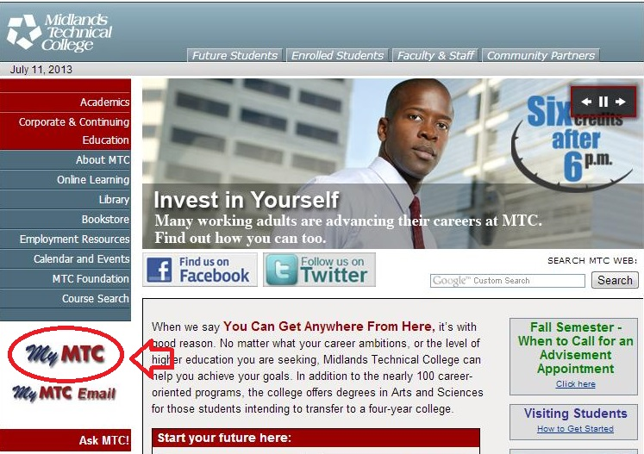

1. Click on MyMTC.

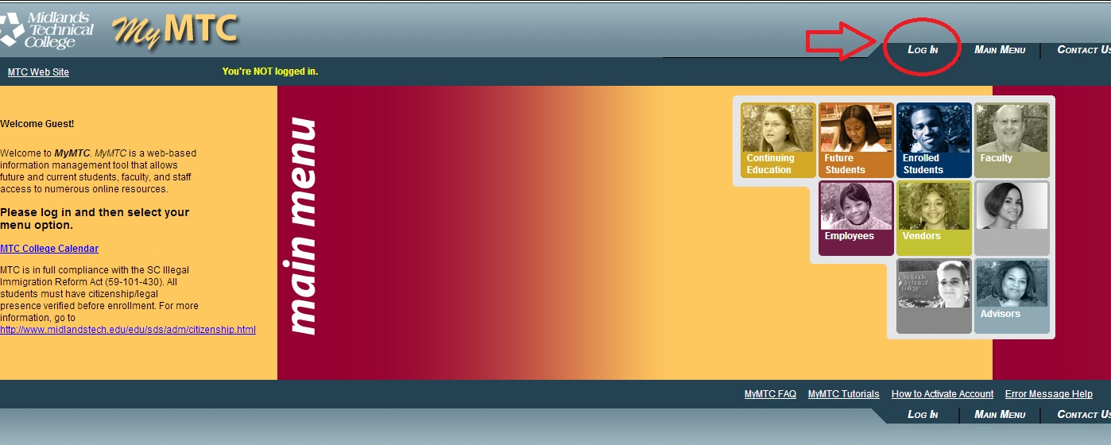

1. Click Login:

Enter your username and password. Activation instruction are found in a link at the bottom of the page:

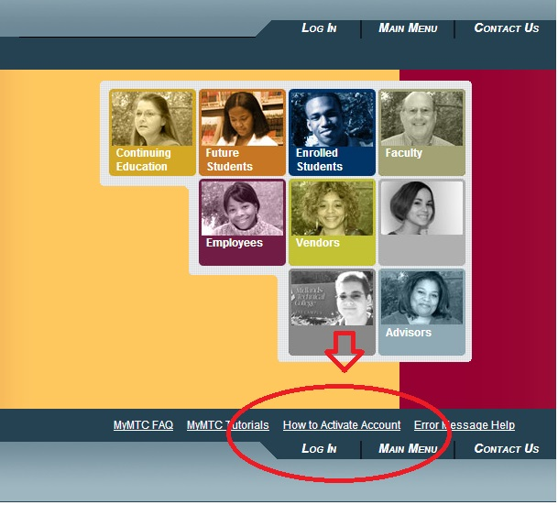

**When you change your password remember what it is.**

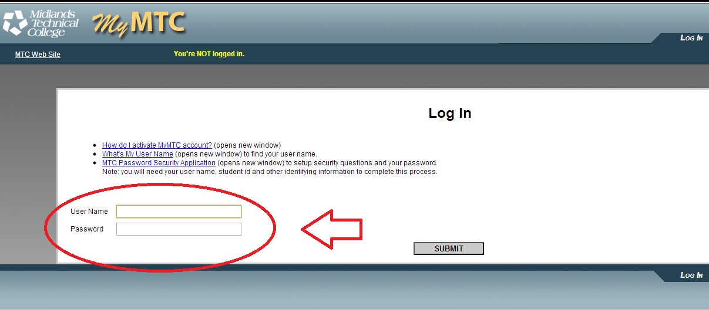

1. Click submit and MyMTC again be will be on the screen. Click Faculty.

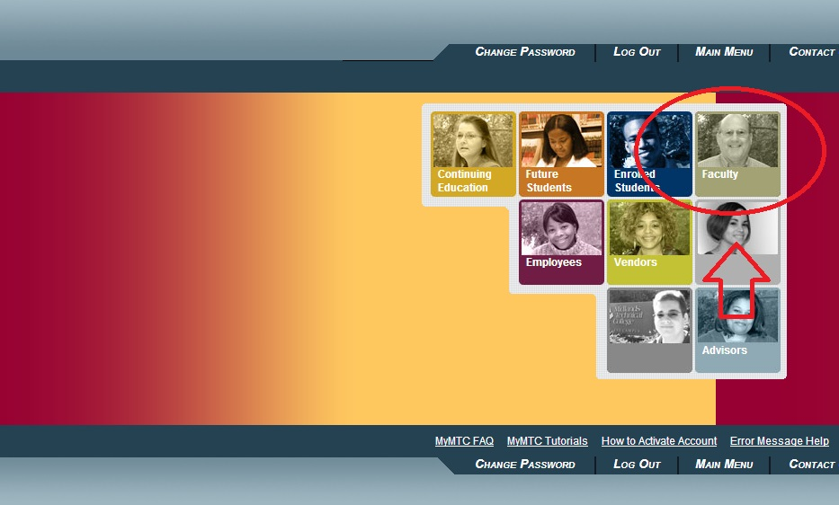

1. You will find the information you need:

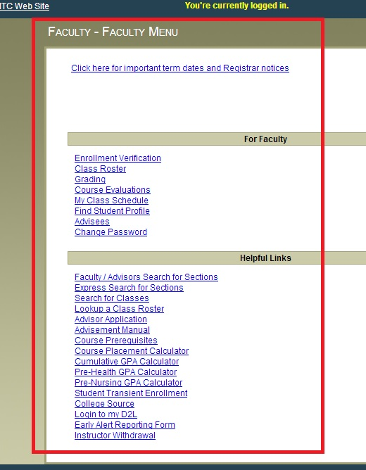

If you wish to access MyMTC through the intranet:

<http://inside.midlandstech.edu/>

Username: mtc Password: inside

Once you have reached the Intranet, click on MyMTC in Quick Links on right side of screen:

**TIPS and HINTS for MTC Online**

1. Do not wait until the last minute to do Enrollment Verifications. **Remember that Enrollment Verifications are tied to Financial Aid as is keeping attendance and withdrawing students appropriately.**
2. **You can now WITHDRAW students in MyMTC.**
3. Course Evaluations are accessible after grading is done.
4. When putting in final grades have all information including LDA (Last Day of Attendance) handy.
5. **If you have trouble call the IRM Help Desk – 7888 (on campus) 738-7888 (off campus).**

**DESIRE 2 LEARN (D2L)**

**URL:** [**https://elearn.midlandstech.edu/d2l/login**](https://elearn.midlandstech.edu/d2l/login)

1. Or, navigate to MTC Homepage and in left side bar, click on “Online Learning”.

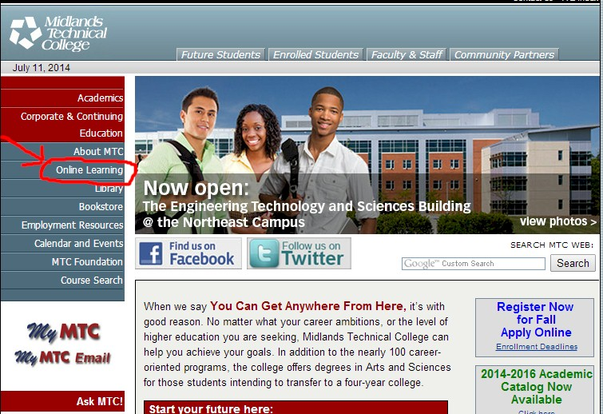

This will take you to the Educational Technology page.

2. You need to click on the button that says “Desire 2 Learn (D2L)”.

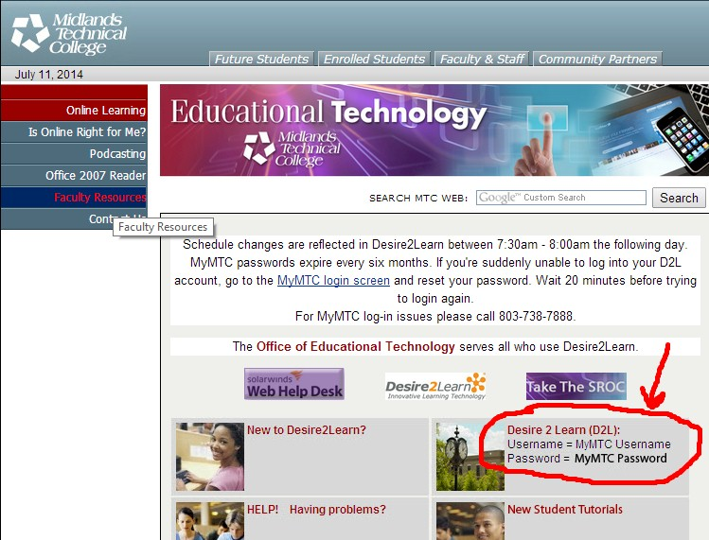

That will take you to the login page for D2L.

3. I f this is your first time logging in, please follow the instructions. Otherwise LOG IN.

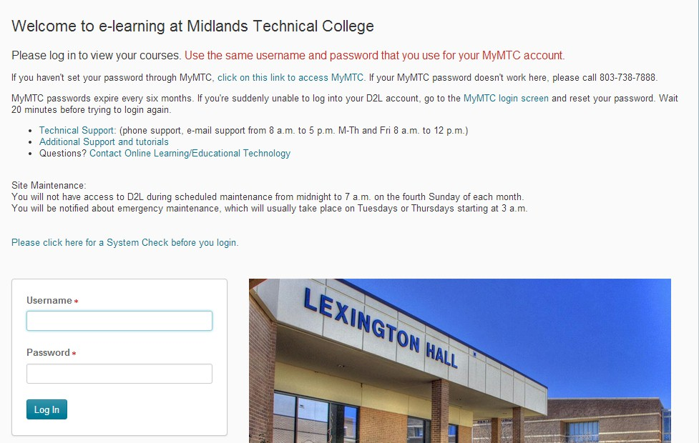

This takes you to the Home page of D2L.

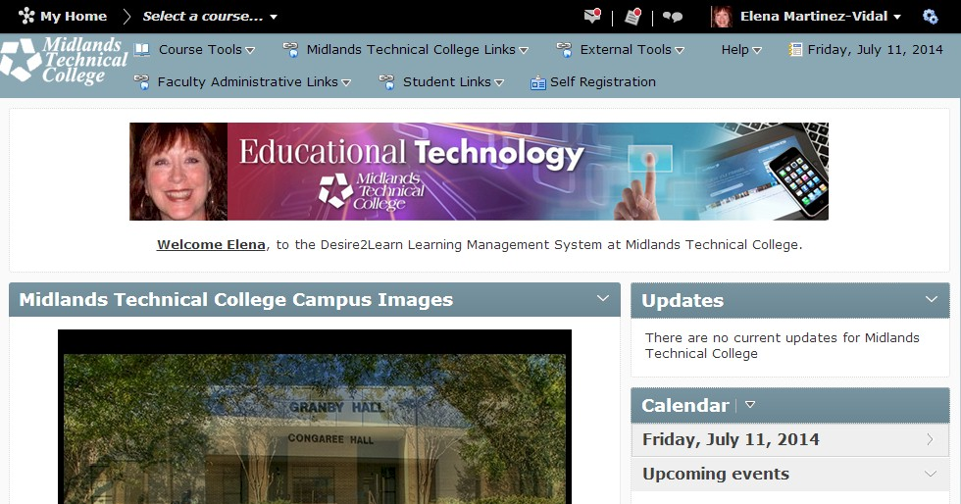

4. You will need to scroll down the page to the bottom to find your classes.

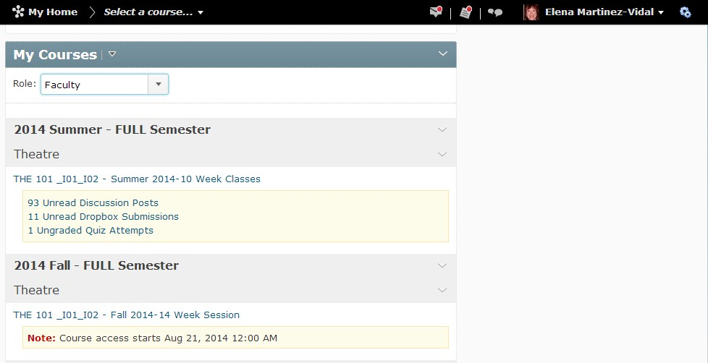

5. To find the Humanities Departmental Course, change your Role to Student.

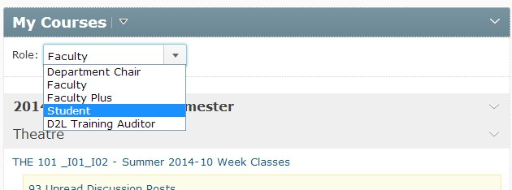

6. You will see the Humanities Departmental Course. Click on it to go to the Home page.

To find content, go to “Content”. If you do not have this, contact the Department Chair to be put into the course.

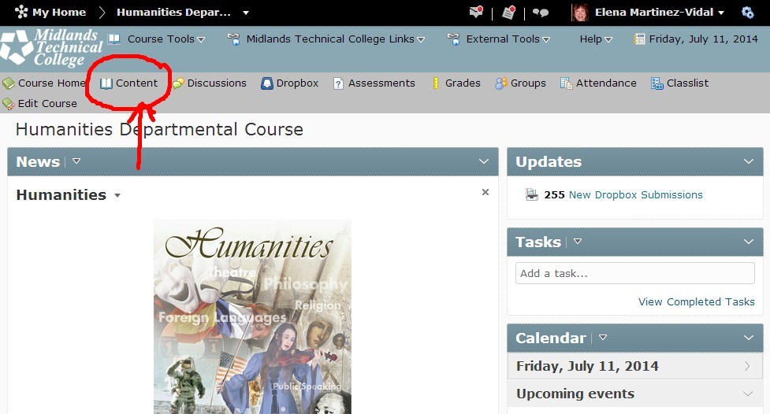

###### 7. In Content you will find Syllabi, Information on how to use Excel, SLO information and Learning Modules with educational articles for your perusal.

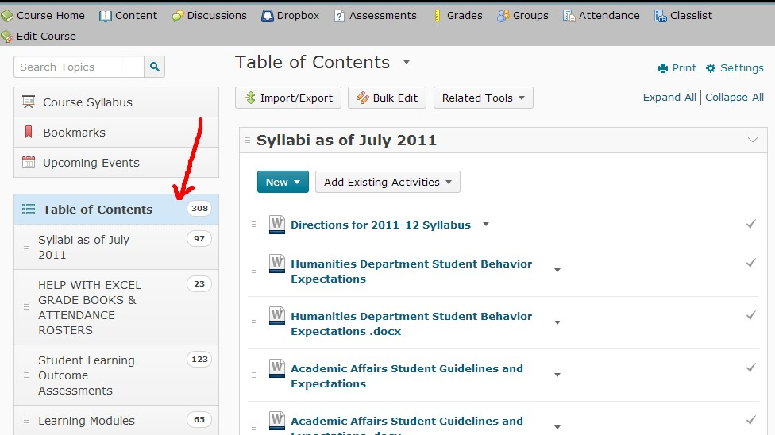

8. To upload (syllabi, grade books, attendance, final exams, SLO grids) go to the Dropbox.

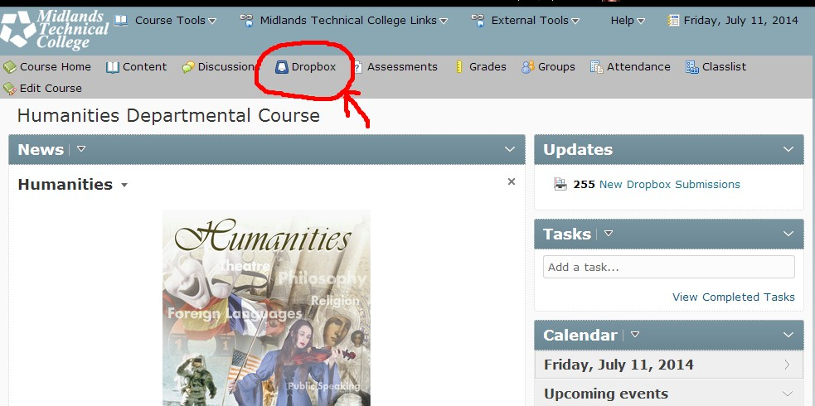

###### 9. The very first area is called “A Semester Information”. Here is where you put semester syllabi, grade books, attendance and final exams in the appropriate semester. Underneath are the Disciplines and courses for SLO upload.

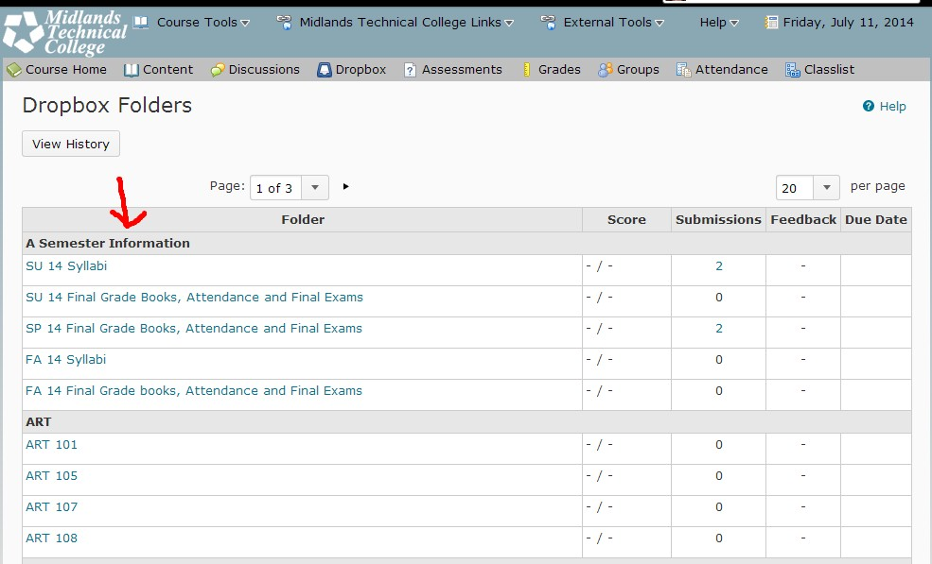

**How to Upload**

1. Click the appropriate box into which you want to upload your files. You will be taken to the following page where you click “Add a File”.

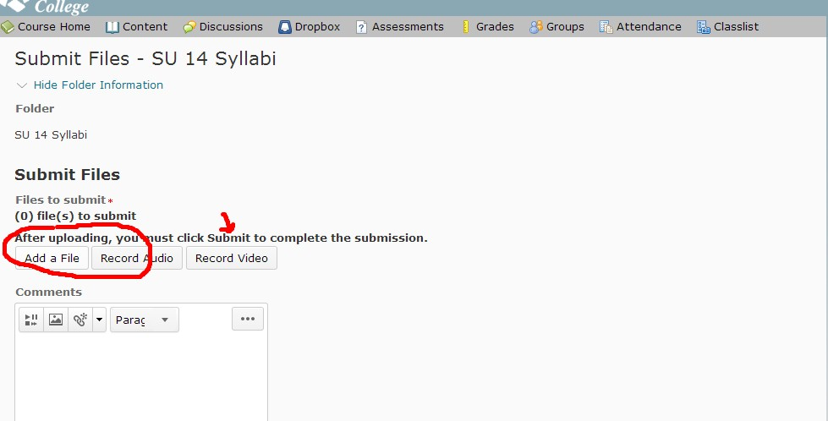

2. This will come up. Click “Upload” and navigate on your computer to where your files are located.

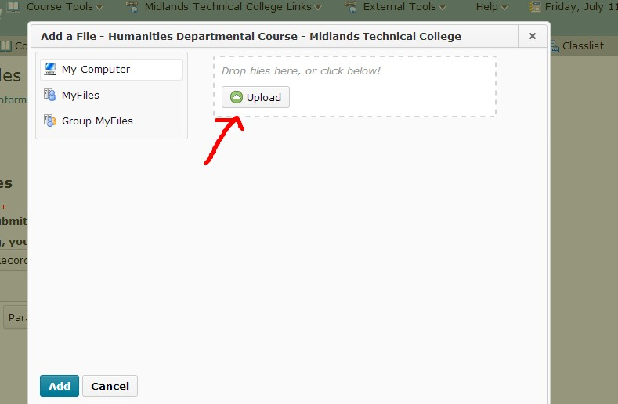

3. Once you have uploaded all the files, click “Add”.

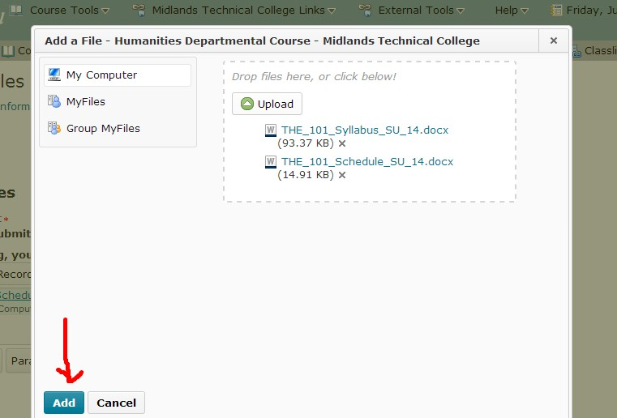

4. This is the Submit Files page. Click Submit.

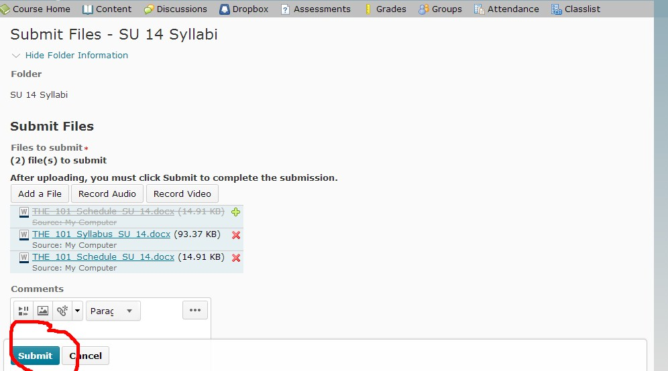

5. At that point you will get confirmation that the file submission was successful and you will also get an email to the address inside your D2L email. Be sure to click done.

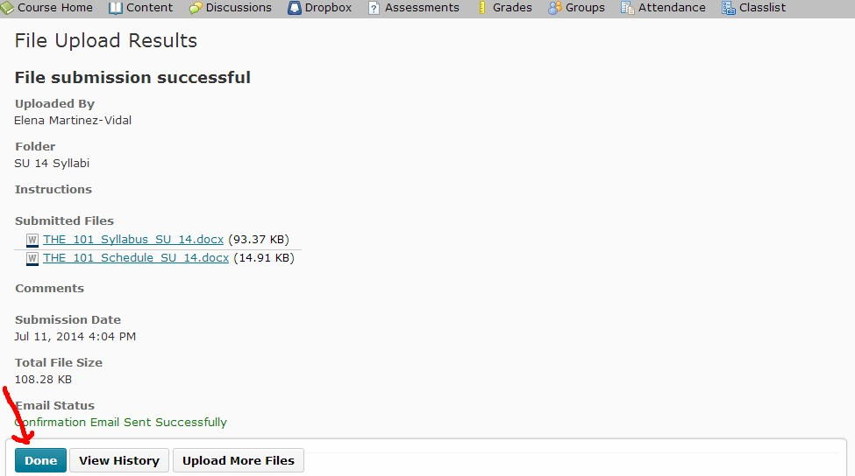

6. You will be taken back to the Home page where you can Logout.

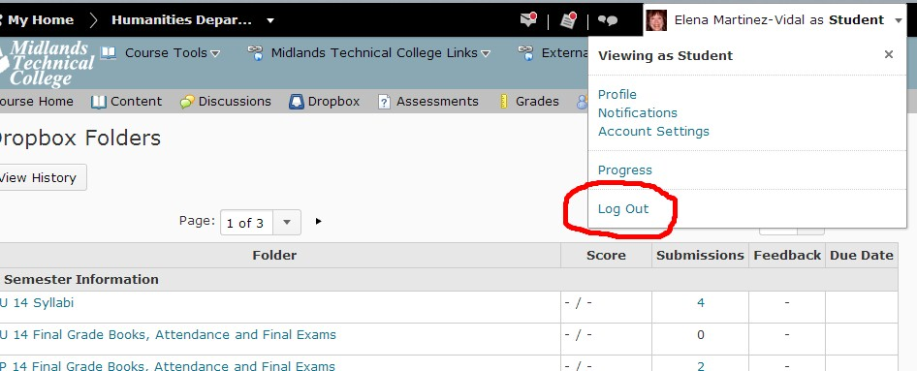

###### CLASS CANCELLATION PROCEDURES

**College Closing Information**

The College may be closed on account of inclement weather. This news should be available on the website at http://www.midlandstech.edu, at the main phone number at 738-1400, and announced on WIS-TV and radio. Please check frequently in changeable weather for closings and re-openings. If the College closing or reopening means that you will have at least 30 minutes of a class, you should plan to meet the class.

You can also sign up for MTC Alerts! In the Intranet.

**Faculty Cancellation of Class**

Regular and punctual class attendance is expected of all faculty. Faculty are expected to teach ALL class periods scheduled for the semester, and classes must meet on time for the full time. Please do not miss class unless you have unavoidable, unforeseeable emergencies; we do not offer paid sick leave to part-time faculty. If a class is cancelled, the hours will be deducted from your pay. If you make prior arrangements to have someone cover your class, be sure that I know about these. In an emergency, please use these procedures to cancel a class—**do NOT leave a message for the department chair, because she may not get messages that day.**

**Canceling Classes**

**After 8:00 a.m. and Before 4:30 p.m.**

**Responsibility of Faculty in Canceling Classes:**

1. Call Monica Boucher-Romano (AC) at 822-3357 or Lisa Cheeks (BC) at 738-7684 to request that Class Cancellation notices be posted for your classes.

## 

If the Administrative Assistant/Specialist for your department is not available, leave a voice mail to notify the department that you are out. HOWEVER, don’t assume that a voice mail to that person means that your students will be notified. The Administrative Assistant/Specialist may be out of the office that day or otherwise unavailable to post a notice outside of your classroom. If you do not talk to the Administrative Assistant/Specialist in person or receive a return call from her within a few minutes of your message, please go to the next step.

1. If you do not speak to your Department's Administrative Specialist, call the Administrative Specialist/Assistant for another Department to request that Class Cancellation notices be posted.

## **Department AC -- Building BC -- Building**

Developmental Studies 822-3539 (AC) 738-7664 (WM)

English 822-3357 (RO) 738-7667 (WM)

Math 822-3357 (RO) 738-7689 (LET)

Science 822-3548 (RO) 738-7689 (LET)

Social & Behavioral Sciences 822-3292 (RO) 738-7612 (WM)

Transfer 822-3293 (RO) 738-7612 (WM)

1. If all else fails, notify Security to request that Class Cancellation notices be posted: 738-7850.

**Canceling Classes**

**Before 8:00 a.m.**

**Responsibility of Faculty in Canceling Classes:**

TIME OF CALL: If at all possible, please observe this time guideline, but it is essential to make the call in any case. To cancel an 8 AM class, please make the call between 7:30 AM and 7:45 AM. After 7:45 AM, the Admin. Asst. may be posting notices.

WHO TO CALL:

1. Arts & Sciences/Transfer 822-3357 (RO) 738-7612 (WM)

2. If all else fails, notify Security to request that Class Cancellation notices be posted: 738-7850.

3. If you do not speak to someone in person by 8 AM, please follow directions for 8-4:30 calls, above.

# Canceling Classes

**After 4:30 p.m.**

**Responsibility of Faculty in Canceling Classes:**

TIME OF CALL: If at all possible, please observe this time guideline, but it is essential to make the call in any case. To cancel a 6 PM class, if possible, call between 8 and 4:30, and follow the guidelines for those times listed above. If you must call after 4:30, please make the call before 5:45 PM. After 5:45 PM, the Admin. Asst. may be posting notices. If you do not speak to someone in person or receive a call back, please call Security, below.

WHO TO CALL:

1. Arts & Sciences/Transfer 822-3357 (RO) 738-7612 (WM)

2. If all else fails, notify Security to request that Class Cancellation notices be posted: 738-7850.

**USING COPY FACILITIES**

**You will need to get your specific copy code from Lisa Cheeks or Elena Martínez-Vidal.**

**COPYRIGHTED MATERIALS:** If you are copying or otherwise incorporating materials you did not create yourself, including scanning pictures or documents for online or multimedia use, you must be sure that you are observing the legal guidelines for this use. Please go to:

<http://www.lib.midlandstech.edu/?General+Copyright+Information>

The library has consolidated information about copyright and the TEACH act as well as other copyright areas. Be sure you are in compliance at all times to the best of your ability.

**PHOTOCOPYING:** Computers are available in the Adjunct workrooms for you to develop materials, and satellite copiers are available throughout the campus for small emergency copy tasks. However, copies at those machines are .05 per sheet; in the Copy Center, the cost is .03 per sheet. You must use the Copy Center in Media Services for more than 35 copies (total: that means 35 copies of one sheet, one copy of 35 sheets, etc.).

Selling packets to students: If you use a large number of handouts, consider having them copied, bound, and sold as a unit to the students through the books store. It is usually very cheap for a student to buy one packet, but it can be very expensive for the college to copy enough packets for all students. See details at

<http://inside.midlandstech.com/bookstore/custompublishing.htm>

(you will need to use intranet username and password – mtc/inside)

In order to custom publish you will need to fill out a **Midlands Technical College Reproduction Copyright and Patent Assurance**.

**EMAILING COPIES:** Attach **material to be copied and the Media Services Request Form to an email addressed to Morris Lewis, Manager of Media Services (**[**lewism@midlandstech.edu**](mailto:lewism@midlandstech.edu)**).** This is the easiest and safest method of getting copies.

**Get the Media Services Request Form at** [**http://inside.midlandstech.com/mediaservices/insdel_cc_reqform.htm**](http://inside.midlandstech.com/mediaservices/insdel_cc_reqform.htm)

You will be asked to verify using:

Username: mtc

Password: inside

You can also send your request with materials to the copy center. On Airport Campus you may send or drop off at the Copy Center. On Beltline Campus, please be sure you send materials at least 48 hours before or more.