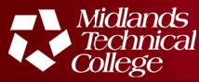 

Midland Technical College Mission Statement

Midlands Technical College is a comprehensive, multi-campus, public, two-year college serving the primary region of Richland, Lexington and Fairfield counties of South Carolina. College programs and services provide accessible, affordable, high quality post-secondary education that prepares a diverse student population to enter the job market, transfer to senior colleges and universities, and achieve their professional and personal goals. Through its programs and services, the college equitably provides higher education opportunities and strengthens the economic and social vitality of the community.